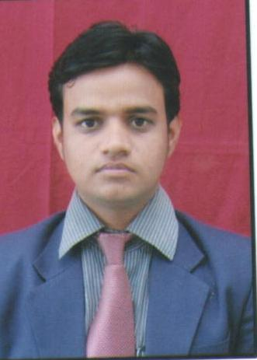**CURRICULUM VITAE**

**VISHAL SURYAKANT WABLE**

**Mobile No**.:- +91- 9922890120. +91-8975589696

**E-mail ID**: - [vwable96@gmail.com](mailto:vwable96@gmail.com)

**Objective**

To work challenging field, this will enable me to utilize my knowledge and skill that will contribute to the organizational growth and help me in building a result-oriented professional career.

**Educational Details**

|  |  |  |  |  |
| --- | --- | --- | --- | --- |
| **Examination.** | **College/School** | **Board / University** | **Year of Passing** | **Percentage**  **%** |
| MBA | S.V.P.M. Institute of Management Malegaon(Bk) | Pune University | 2011-2013 | 57% |
| BBA | S.V.P.M. Institute of C.C.S.C.E Malegaon(Bk) | Pune University | 2008-11 | 52.33 % |
| H.H.C. | Shardabai Pawar Vidyalaya, Shivnagar | Pune Board. | 2005-06 | 51.50% |
| S.S.C. | Shardabai Pawar Vidyalaya, Shivnagar | Pune  Board | 2003-04 | 46.13% |

|  |
| --- |
| **Experience** |

* **Axis Bank Ltd** Baramati as the post of **Business Development Exicutive**. Developing customer acquisition for the branch. Acquisitions of Current Account & Saving Accounts through open market along with cross selling of other products of the bank & acquisition of high end current accounts through open market lead generation with developing customer relationship for the bank **(15th May 2013 To 9th may 2014)**
* Currently working with **Yes Bank Ltd** Baramati as the post of **Senior Officer (Client Relationship Partner).** Developing customer acquisition for the branch. Acquisitions of Current Account & Saving Accounts through open market along with cross selling of other products of the bank & acquisition of high end current accounts through open market lead generation with developing customer relationship for the bank **(12th May 2014 To Till Date)**

**Other Qualification**

* MS-CIT Computer Course passed with 72.00% in October 2006.

**Extra Activities**

* Played VOLLYBALL from District level & win First Prize in 2001.
* Played VOLLYBALL from District level & win First Prize in 2006.

**Project**

* Study of Customer Satisfaction for Maruti Vehicles at Baramati Region.
* Study of Customer Satisfaction & Market Potential for Spark of Chevrolet at Baramati Region.
* A Study of Market Potentials & Customer Perception for MRF Tyers in Baramati Area.

**Personal Details:**

|  |  |
| --- | --- |
| **Name** | **: -** Vishal Suryakant Wable |
| **Permanent Address** | **: -** A/p. - Sangavi, Tal. - Baramati,  **:** - Dist. – Pune Pin. - 413 102 |
| **Date of Birth** | **:** - 30th March 1989 |
| **Nationality** | **:** - Indian |
| **Gender** | **: -** Male |
| **Languages Known** | **: -** English, Marathi, & Hindi. |
| **Marital Status** | **:** - Unmarried |
| **Cast** | **:** - Hindu-Maratha |

**Declaration:**

I, Vishal Wable hereby declare that the above information is true to the best of knowledge and belief. If any of this information found to false or incomplete I will be responsible for it.

**Place :-Baramati**

**Date :- 28/12/2014**

**Vishal Wable.**